**PRESS RELEASE*:***

*For publication 28th November, 2023*

**Busara Promotions Announces Yusuf Mahmoud as New Board Member.**

After two decades of leadership as the CEO of Busara Promotions and Sauti za Busara festival director, earlier this year Yusuf Mahmoud announced his retirement, effective July 2023. Mahmoud will now serve as an active board member following his retirement as CEO, after being elected with unanimous votes from the board of trustees to Busara Promotions.

Yusuf Mahmoud is a highly respected music industry veteran who brings a wealth of experience and entrepreneurial mindset to the industry, especially for women, young and emerging talents that will continue to propel Busara Promotions and Sauti za Busara festival into the future. Yusuf is excited to continue with the team and build on the legacy, momentum and explosive growth that Sauti za Busara is experiencing.

He relocated from the UK, his home country, to Zanzibar in 1998 and five years later set up Busara Promotions, an NGO working in East Africa to strengthen appreciation for African music and develop local skills and networks.

In 2007, he was presented with a World Shaker Award at the BBC World Music Awards in recognition of his enormous contribution to the local scene in Zanzibar and the world music scene globally.

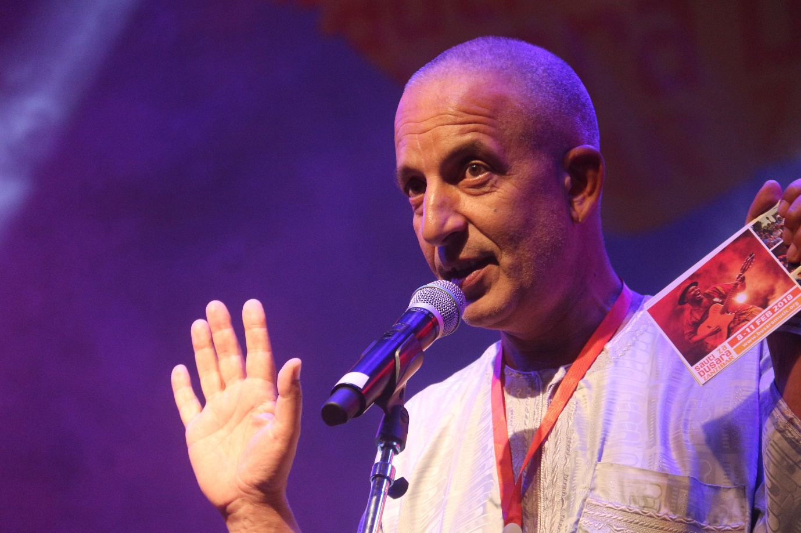

Yusuf joins the board as the festival prepares its 21st edition scheduled to shake the walls of Stone Town in Zanzibar during 9 to 11 February 2024.

On his new appointment Mahmoud commented, “After twenty years at the helm, I am happy to continue as a board member with Busara Promotions, to offer guidance and support when required. At the same time, I am 100% confident in the new leadership’s capabilities and dedication to keep the organisation moving forward with fresh energy and new ideas.”

He continued, “Our success over the years was always reliant on inputs from diverse stakeholders, including staff and crew members, public and private sector partners, local and international artists, media organisations and audiences from across East Africa and the world. I hope and pray the Busara Team can still count on the collaboration and support of many well-wishers, to keep our highly-acclaimed festival growing from strength to strength.”

The 21st Sauti za Busara festival, 9 - 11 February 2024 is powered by Fumba Town - a project by CPS, Ignite Culture, Embassy of France, Institut Français, ST Bongo Tv, Serikali ya Mapinduzi ya Zanzibar, Zanzibar Serena Hotel, Coconut FM, Zanlink, Emerson Zanzibar, 2Tech Security, Stawi Hub and more.

NOTE TO EDITOR: For hi-res photos, see [www.busaramusic.org/downloads](http://www.busaramusic.org/downloads)